**Module:**

## **Website & Mobile Design & Development (2017)**

**Group CA2 -Website**

**Site Structure & Navigation**

**Continuous Assessment 2**

**Value: 30%**

**Lecturer: Jelena Vasic**

**Submission Date: 10th November 2017**

**Student Details:**

**Carl Promnitz X00130365**

**Sean Slattery X00136210**

# **Sections**

[1a - 1] - User Types

[1a - 2] - Functional Requirement List

[1a - 3] - Site Structure

[1a - 4] - Navigation Element Tables

[1a - C] - Contributions

**[1a-1]- User Types**

There are three User Types that will interact with the website:

* Non-Account Users (Lowest Level)
* Account Users (Medium Level)
* Administrators (Highest Level)

**[1a-2]- Functional Requirement List**

**(A.) Non-Account Users (Lowest Level)**

These users have limited user access to the website as they can only read and navigate the content of the website(via the Navigation bar and Search bar), hence their low level access to the site.

While they cannot interact with the site further than this, they can sign up to create an account on the site and become a member. This will allow them to partake in discussions with other account members and the admins of the site in the comment sections at the bottom of each team or tournament page.

**(B.) Account Users (Medium Level)**

Account users are the non-account users that have created an account and are now members of the website.

They now have medium level access to the website as they can now take part in discussions and leave comments, along with the actions allowed to the non-account users. This allows them to communicate with other account users/ website members and the administrators.

**(C.) Database/Site Administrators (Highest Level)**

These are the users who manage the website’s layout and content.

They too have access to the comments section of each page, but their high level access comes from their ability to actively modify the entire website. This includes the layout, content and the user base of the website.

The admins can also modify the database of accounts that are created on the website, being able to input the newly created account information, as well as updating and deleting.

They will require to sign in their account aswell, but the database containing the information could either be separate of part of the same database with the user accounts. (**NOTE:** This part may change after the later changes of the design comes together.)

**[1a-3]- Site Structure**

The structure of the site will be based on a hierarchical structure. The website will consist of a single home page that allows you to use the top navigation bar that displays each chosen game that has major eSports scenes right now to navigate the site. The Search bar will allow the users to also search for their desired page without the need to access the navigation bars. They will be displayed in a left-to-right fashion on the top navigation bar, with drop-down menus accompanying each game when the user hovers the cursor, or clicks on the game’s bar, revealing the links to the Teams and Tournaments for the game in question. While the search bar will allow them to find the page they want without using the navigation bars.

After the user chooses what game, team or tournament they want to read about on our website, the page will still consist of the same navigation styling. However, there will be links on the current page they are on that will lead to the games, teams or tournaments official website that can give further information than what the our website has by clicking on the image of the team.

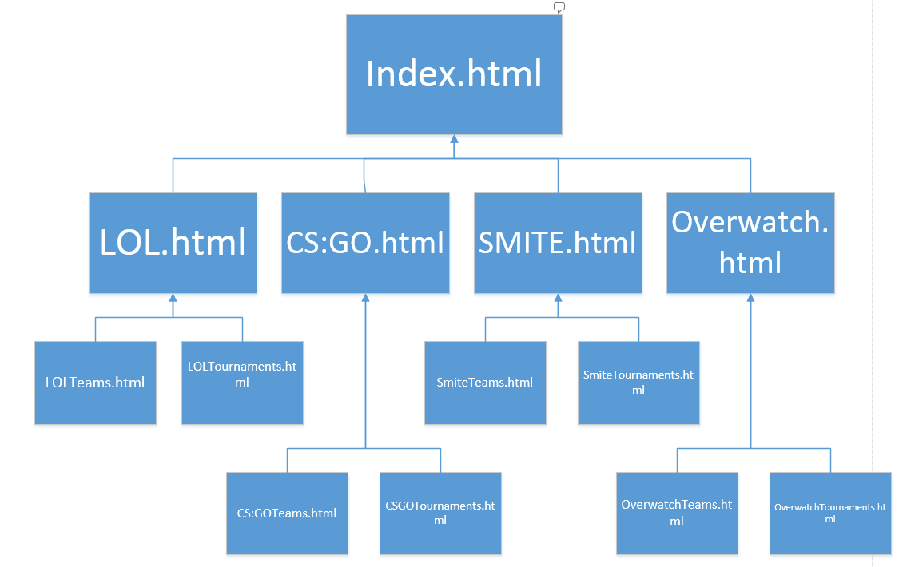

**[1a-4]- Navigation Element Table**

|  |  |  |
| --- | --- | --- |
| **Name of Element** | **Description and Links** | **Included in pages** |
| Main Navigation bar | Home (Target:Index.html) | ALL |
|  | LOL (Target:LOL.html) |  |
|  | LOLTeams (Target:LOLTeams.html) |  |
|  | LOLTournaments (Target:LOLTournaments.html) |  |
|  | CSGO (Target:CSGO.html) |  |
|  | CSGOTeams (Target:CSGOTeams.html) |  |
|  | CSGOTournaments (Target:CSGOTournaments.html) |  |
|  | SMITE (Target:SMITE.html) |  |
|  | SMITETeams (Target:SMITETeams.html) |  |
|  | SMITETournaments (Target:SMITETournaments.html) |  |
|  | Overwatch (Target:Overwatch.html) |  |
|  | OverwatchTeams(Target:OverwatchTeams.html) |  |
|  | OverwatchTournaments (Target:OverwatchTournaments.html) |  |

The only navigation bar would be the top/main navigation bar. This bar will be constant throughout the website. Allowing the users to navigate the website without the need to backtrack through previously visited page.

**[1a-C]- Contributions**

**[1a-1] -Sean Slattery(X00136210) -** Typed up the information in the document.

**[1a-2] -Sean Slattery(X00136210) -** Typed up the information in the document.

**[1a-3] -Carl Promnitz(X00130365) -** Done the Site Structure Diagram in Microsoft Visio. Information in document was written up by Sean Slattery(X00136210).

**[1a-4] -Carl Promnitz(X00130365) -** Done the Navigation Table.